🚀 POST 11 — Security for MCP, Agents, RAG & Multi-Agent Systems  
[**hashtag#AI**](https://www.linkedin.com/search/results/all/?keywords=%23ai&origin=HASH_TAG_FROM_FEED) [**hashtag#GenAI**](https://www.linkedin.com/search/results/all/?keywords=%23genai&origin=HASH_TAG_FROM_FEED) [**hashtag#Security**](https://www.linkedin.com/search/results/all/?keywords=%23security&origin=HASH_TAG_FROM_FEED) [**hashtag#Agents**](https://www.linkedin.com/search/results/all/?keywords=%23agents&origin=HASH_TAG_FROM_FEED) [**hashtag#SystemDesign**](https://www.linkedin.com/search/results/all/?keywords=%23systemdesign&origin=HASH_TAG_FROM_FEED) [**hashtag#EnterpriseAI**](https://www.linkedin.com/search/results/all/?keywords=%23enterpriseai&origin=HASH_TAG_FROM_FEED)  
  
As AI systems move closer to core business workflows, security becomes architecture, not an afterthought.  
  
Agentic systems introduce new attack surfaces that traditional security models don’t fully cover.  
  
Here’s the practical security blueprint 👇  
  
🔵 1️⃣ Prompt Injection Is the New SQL Injection  
LLMs can be manipulated through inputs, documents, or tools.  
  
Common attack paths:  
a) Malicious user prompts  
b) Poisoned RAG documents  
c) Hidden tool instructions  
Defenses that work:  
 ✔ Input validation & prompt hardening  
 ✔ Instruction separation (system vs data)  
 ✔ Output validation & policy checks  
Never trust raw input — even from “internal” sources.  
  
🔵 2️⃣ Sandboxed Tool Execution (Critical for Agents)  
Agents that execute tools must be constrained by design.  
  
Best practices:  
a) Isolated sandboxes  
b) Strict input/output schemas  
c) No filesystem, network, or shell access  
d) Allowlisted tools only  
Agents should request capabilities, not assume them.  
  
🔵 3️⃣ MCP Authentication & Trust Boundaries  
MCP makes tools and resources discoverable — access control matters.  
  
Security controls include:  
a) Authenticated MCP endpoints  
b) Tool-level authorization  
c) Role-based access per agent  
d) Scoped tokens with expiration  
MCP servers must be treated like production APIs.  
  
🔵 4️⃣ Data Governance for RAG Pipelines  
RAG systems can accidentally leak sensitive data.  
  
Governance strategies:  
 ✔ Document classification  
 ✔ Chunk-level access control  
 ✔ Redaction before embedding  
 ✔ Retrieval audit logs  
If data shouldn’t be seen by a user, it shouldn’t be retrievable.  
  
🔵 5️⃣ Preventing Model Overreach  
LLMs tend to be over-confident by default.  
  
Controls include:  
a) Confidence thresholds  
b) Refusal policies  
c) Deterministic fallbacks  
d) Human-in-the-loop escalation  
A secure system knows when NOT to answer.  
  
🔵 6️⃣ VPC-Only & Private Inference  
For regulated environments, inference boundaries matter.  
  
Patterns include:  
a) VPC-only endpoints  
b) On-prem / private GPU inference  
c) No outbound internet  
d) Controlled tool egress  
Compliance shapes architecture.  
  
🔵 7️⃣ Zero-Trust for Agent Execution  
In agentic systems:  
a) Every tool call is untrusted  
b) Every action is validated  
c) Every capability is explicit  
Zero-trust means least privilege + observability.  
  
🔵 8️⃣ Principle: Secure the System, Not Just the Model  
Most AI breaches happen around the model, not inside it.  
Secure AI systems:  
 ✔ Constrain capabilities  
 ✔ Validate inputs & outputs  
 ✔ Isolate execution  
 ✔ Enforce governance  
Security enables scale.  
  
🔽 Up Next: Post 12 — Basic Principles of AI Solution Design (Aravind’s Framework)  
 Stay tuned.  
  
[**hashtag#AI**](https://www.linkedin.com/search/results/all/?keywords=%23ai&origin=HASH_TAG_FROM_FEED) [**hashtag#GenAI**](https://www.linkedin.com/search/results/all/?keywords=%23genai&origin=HASH_TAG_FROM_FEED) [**hashtag#Security**](https://www.linkedin.com/search/results/all/?keywords=%23security&origin=HASH_TAG_FROM_FEED) [**hashtag#Agents**](https://www.linkedin.com/search/results/all/?keywords=%23agents&origin=HASH_TAG_FROM_FEED) [**hashtag#RAG**](https://www.linkedin.com/search/results/all/?keywords=%23rag&origin=HASH_TAG_FROM_FEED) [**hashtag#MCP**](https://www.linkedin.com/search/results/all/?keywords=%23mcp&origin=HASH_TAG_FROM_FEED) [**hashtag#EnterpriseAI**](https://www.linkedin.com/search/results/all/?keywords=%23enterpriseai&origin=HASH_TAG_FROM_FEED) [**hashtag#SystemDesign**](https://www.linkedin.com/search/results/all/?keywords=%23systemdesign&origin=HASH_TAG_FROM_FEED)

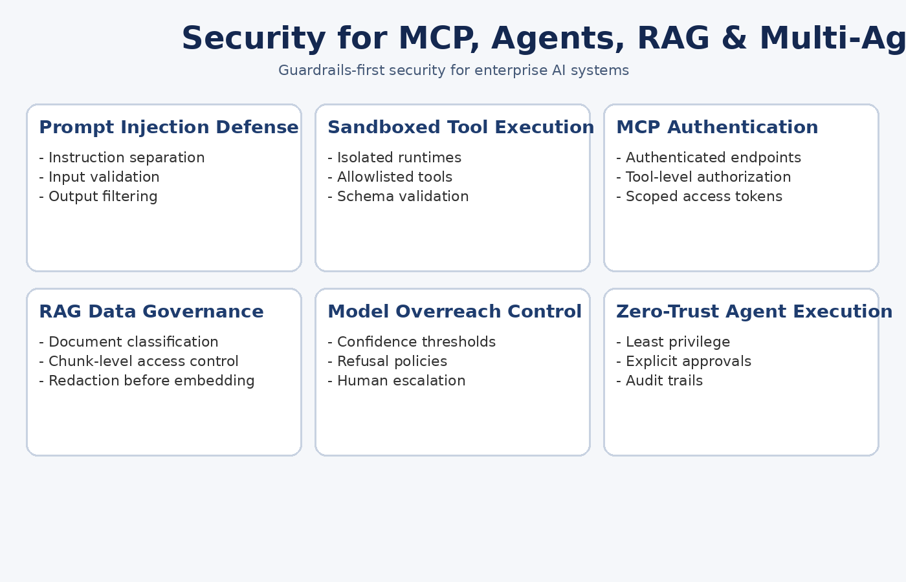

🚀 POST 12 — Basic Principles of AI Solution Design (Aravind’s Framework)  
[**hashtag#AI**](https://www.linkedin.com/search/results/all/?keywords=%23ai&origin=HASH_TAG_FROM_FEED) [**hashtag#GenAI**](https://www.linkedin.com/search/results/all/?keywords=%23genai&origin=HASH_TAG_FROM_FEED) [**hashtag#SystemDesign**](https://www.linkedin.com/search/results/all/?keywords=%23systemdesign&origin=HASH_TAG_FROM_FEED) [**hashtag#Agents**](https://www.linkedin.com/search/results/all/?keywords=%23agents&origin=HASH_TAG_FROM_FEED) [**hashtag#EnterpriseAI**](https://www.linkedin.com/search/results/all/?keywords=%23enterpriseai&origin=HASH_TAG_FROM_FEED) [**hashtag#Architecture**](https://www.linkedin.com/search/results/all/?keywords=%23architecture&origin=HASH_TAG_FROM_FEED)  
  
After building and studying multiple AI systems, one lesson stands out:  
Most AI failures are design failures — not model failures.  
  
Over time, I’ve converged on a simple framework that consistently works in enterprise settings.  
  
Here’s my practical AI solution design philosophy 👇  
🔵 1️⃣ Simple → Useful → Reliable → Scalable  
  
Many teams try to jump straight to “scalable.”  
That’s backwards.  
  
The correct order is:  
a) Simple: minimal moving parts  
b) Useful: solves a real problem  
c) Reliable: predictable behavior under failure  
d) Scalable: only when demand proves it  
If it’s not reliable, scaling only multiplies failure.  
  
🔵 2️⃣ Minimize Agent Count by Default  
Agents are powerful — but expensive.  
Each agent adds:  
a) Latency  
b) State complexity  
c) Failure surface  
  
Start with one agent.  
Add more only when roles are truly distinct.  
  
More agents ≠ better architecture.  
  
🔵 3️⃣ Start With Retrieval, Then Add Tools  
Most problems are knowledge problems, not reasoning problems.  
Design order:  
 1️⃣ Retrieval (RAG)  
 2️⃣ Tool calls (APIs, functions)  
 3️⃣ Agent planning  
If retrieval solves 80% of the problem, don’t over-engineer the last 20%.  
  
🔵 4️⃣ RAG → Agents → Multi-Agents (As Needed)  
This progression works in practice:  
a) RAG → factual answers  
b) Single Agent → orchestration + decisions  
c) Multi-Agent → role separation at scale  
Skipping steps leads to unnecessary complexity.  
  
🔵 5️⃣ Guardrails-First Thinking  
Every AI system needs:  
a) Input constraints  
b) Output validation  
c) Timeouts & rate limits  
d) Cost and token budgets  
e) Security boundaries  
Guardrails are not optional — they are architecture.  
  
🔵 6️⃣ Design for Failure From Day One  
Failures will happen:  
a) Models hallucinate  
b) Tools fail  
c) Context drifts  
Good systems:  
 ✔ Fail clearly  
 ✔ Recover predictably  
 ✔ Preserve trust  
If failure isn’t designed, it will be discovered in production.  
  
🔵 7️⃣ Principle: AI Is a Distributed System  
Treat AI systems like distributed systems:  
a) Partial failures  
b) Backpressure  
c) State propagation  
d) Consistency trade-offs  
Once you adopt this mindset, architecture decisions become clearer.  
  
🔵 Final Thought  
The best AI systems are:  
a) Boring in architecture  
b) Predictable in behavior  
c) Valuable in outcomes  
Sophistication should emerge from simplicity — not replace it.  
  
🔽 Up Next: Post 13 — Choosing the Right LLM: Evaluation, Latency & Cost Strategy  
 Stay tuned.  
  
[**hashtag#AI**](https://www.linkedin.com/search/results/all/?keywords=%23ai&origin=HASH_TAG_FROM_FEED) [**hashtag#GenAI**](https://www.linkedin.com/search/results/all/?keywords=%23genai&origin=HASH_TAG_FROM_FEED) [**hashtag#SystemDesign**](https://www.linkedin.com/search/results/all/?keywords=%23systemdesign&origin=HASH_TAG_FROM_FEED) [**hashtag#Architecture**](https://www.linkedin.com/search/results/all/?keywords=%23architecture&origin=HASH_TAG_FROM_FEED) [**hashtag#Agents**](https://www.linkedin.com/search/results/all/?keywords=%23agents&origin=HASH_TAG_FROM_FEED) [**hashtag#EnterpriseAI**](https://www.linkedin.com/search/results/all/?keywords=%23enterpriseai&origin=HASH_TAG_FROM_FEED)

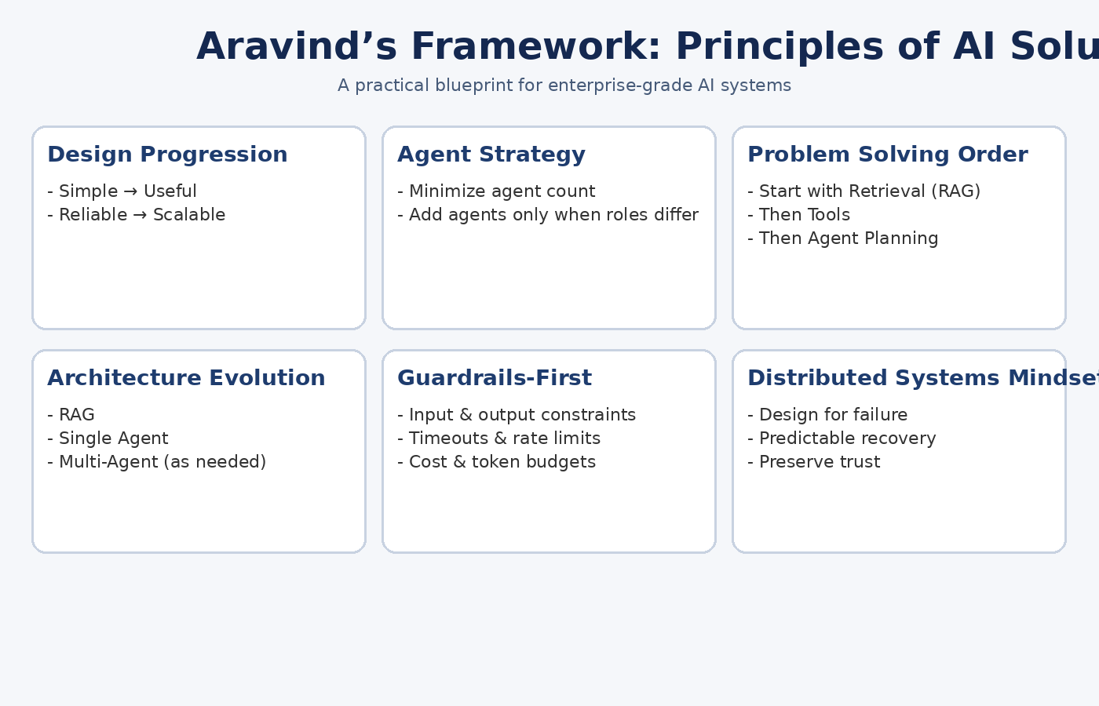

🚀 POST 13 — Choosing the Right LLM: Evaluation, Latency Reduction & Cost Strategy

**#AI** **#GenAI** **#LLM** **#SystemDesign** **#EnterpriseAI** **#Architecture**

One of the most expensive mistakes teams make is asking:

“Which LLM is the best?”

The correct question is:

“Which LLM is right for this task, latency target, and cost envelope?”

Here’s a practical, enterprise-grade approach 👇

🔵 1️⃣ Benchmarks Are Signals — Not Decisions

Benchmarks matter, but only in context.

Use them to compare:

a) Accuracy vs latency

b) Throughput under load

c) Context window behavior

d) Cost per token

Never pick a model only because it tops a leaderboard.

🔵 2️⃣ Map Models to Task Types

Different tasks demand different models.

Examples:

a) Classification / extraction → small, fast models

b) RAG grounding → strong embedding + mid-sized LLM

c) Planning & reasoning → larger models

d) Code or math-heavy tasks → specialized models

One model rarely fits all workloads.

🔵 3️⃣ Latency Reduction Techniques That Actually Work

Latency is not just “model speed.”

Effective techniques:

a) Prompt trimming & context control

b) Streaming responses

c) Request batching

d) Parallel tool execution

e) Local or VPC-based inference

Shaving 200–300ms often matters more than higher accuracy.

🔵 4️⃣ Speculative Decoding & Early Exit

Advanced systems use:

a) Small models to draft

b) Larger models to verify

c) Early stopping on low-confidence paths

This reduces latency without sacrificing quality.

🔵 5️⃣ Quantization as a Performance Lever

Quantization is not just about cost.

Benefits:

a) Faster inference

b) Lower memory usage

c) Better cache locality

Trade-offs must be tested — but gains are often significant.

🔵 6️⃣ Multi-LLM Routing (The Enterprise Pattern)

Production systems rarely rely on a single model.

Routing strategies include:

a) Cheap model for most requests

b) Expensive model for hard cases

c) Fallback models for failures

d) Task-specific model selection

This is how teams balance quality, latency, and cost.

🔵 7️⃣ Cost Strategy: Think in Cost per Outcome

Tokens are easy to measure — outcomes matter more.

Track:

a) Cost per resolved request

b) Cost per workflow

c) Cost per user journey

The cheapest model isn’t always the most cost-effective.

🔵 Principle: Model Choice Is a System Decision

Choosing an LLM is not an ML decision alone.

It’s a systems design trade-off involving:

a) Accuracy

b) Latency

c) Reliability

d) Cost

e) Security

Architects who treat models as interchangeable components build better systems.

🔽 Up Next: Post 14 — GPUs vs TPUs vs Quantization: A Practical Guide

Stay tuned.

**#AI** **#GenAI** **#LLM** **#Architecture** **#SystemDesign** **#EnterpriseAI**

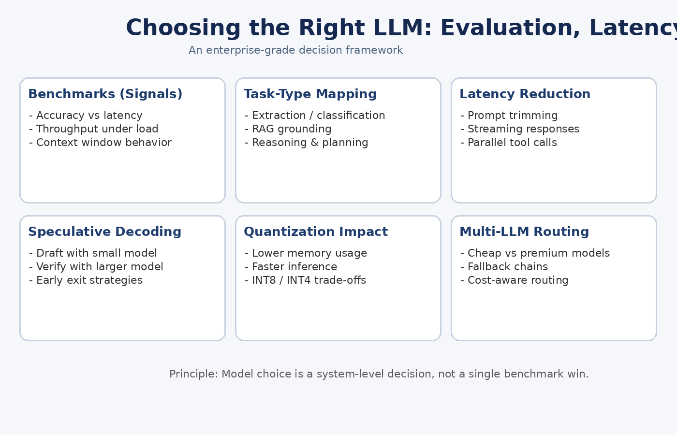

🚀 POST 14 — GPUs vs TPUs vs Quantization: A Practical Guide

**#AI** **#GenAI** **#Infrastructure** **#LLM** **#SystemDesign** **#EnterpriseAI**

As AI workloads move from experiments to production, hardware choices start to matter a lot.

The wrong choice hurts latency, cost, and throughput.

The right one creates massive efficiency gains.

Here’s a practical, no-hype guide 👇

🔵 1️⃣ When GPUs Are the Right Choice

GPUs are the most flexible option.

Best for:

a) LLM inference & fine-tuning

b) Multi-modal models

c) Agent workflows with tool calls

Why:

✔ Broad framework support

✔ Mature ecosystem

✔ Strong batching & parallelism

GPUs are the default for a reason.

🔵 2️⃣ When TPUs Actually Give an Advantage

TPUs shine in specific scenarios.

Best for:

a) Large-scale training

b) Homogeneous, high-throughput workloads

Trade-offs:

a) Less flexible than GPUs

b) Tighter ecosystem coupling

c) TPUs excel when scale and throughput dominate flexibility.

🔵 3️⃣ Quantization: The Real-World Accelerator

Quantization is often more impactful than new hardware.

Benefits:

a) Faster inference

b) Lower memory usage

c) Better cache locality

Common trade-offs:

a) FP16 → safest

b) INT8 → strong performance gain

c) INT4 → aggressive, must validate accuracy

Quantization turns “too big to run” into “cheap to serve.”

🔵 4️⃣ CPU-Only Acceleration (Yes, It’s Real)

For home labs and edge use cases:

a) Quantized models

b) Optimized runtimes

c) Smaller context windows

CPU-only setups can deliver surprisingly usable performance.

🔵 5️⃣ Principle: Optimize the Stack, Not Just the Hardware

The biggest gains usually come from:

a) Quantization

b) Batching

c) Context control

d) Smarter routing

Hardware amplifies good architecture — it doesn’t fix bad design.

🔽 Up Next: Post 15 — Caching Strategies for AI Systems

Stay tuned.

**#AI** **#GenAI** **#LLM** **#Infrastructure** **#SystemDesign** **#EnterpriseAI**

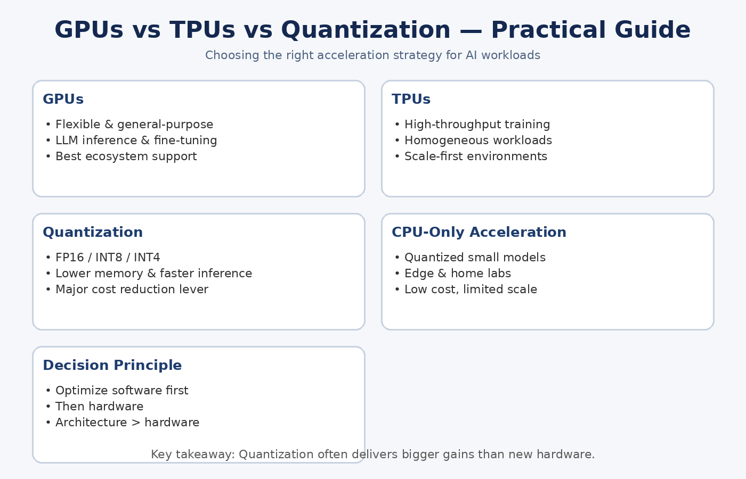

🚀 POST 16 — Databases for AI Systems: RDBMS vs NoSQL vs Object Storage

**#AI** **#GenAI** **#SystemDesign** **#Architecture** **#DataEngineering**

AI systems don’t use one database.

They use multiple storage layers, each optimized for a different kind of data, consistency model, and access pattern.

Here’s the practical way to think about storage in modern AI systems 👇

🔵 1️⃣ RDBMS (Postgres, MySQL, etc.)

Best for: structured, transactional data

Use when you need:

a) Strong consistency (ACID)

b) Referential integrity

c) Auditable state

Common AI use cases:

a) User profiles

b) Permissions & access control

c) Conversation metadata

d) Agent state transitions

👉 RDBMS is the source of truth.

🔵 2️⃣ NoSQL (MongoDB, DynamoDB, Cassandra)

Best for: flexible, evolving schemas

Use when you need:

a) High write throughput

b) Horizontal scale

c) Schema evolution

Common AI use cases:

a) Session context

b) Agent memory (JSON-style)

c) Tool execution logs

d) Event histories

👉 NoSQL works well for semi-structured AI state.

🔵 3️⃣ Object Storage (S3, GCS, Azure Blob)

Best for: large, immutable artifacts

Use for:

a) Documents used in RAG

b) Model binaries & checkpoints

c) Embeddings exports

d) Logs & traces

👉 Object storage is cheap, durable, and infinitely scalable — but not transactional.

🔵 4️⃣ Structured vs Unstructured vs Embeddings

Think in terms of data shape:

a) Structured → RDBMS

b) Semi-structured → NoSQL

c) Unstructured (PDFs, images) → Object storage

d) Embeddings → Vector DB (with metadata elsewhere)

No single store does all of this well.

🔵 5️⃣ ACID vs BASE in AI Pipelines

a) ACID: correctness, consistency, governance

b) BASE: scale, speed, flexibility

AI systems usually mix both:

a) ACID for control & policy

b) BASE for inference & memory

🔵 6️⃣ Storing Conversation & Agent State

A common pattern:

a) RDBMS → identity & permissions

b) NoSQL → session / agent memory

c) Object storage → artifacts & logs

Separation improves reliability and debuggability.

🔵 Principle: Store Data Where It Fits Best

Don’t force AI workloads into one database.

Good AI architecture uses the right store for the right responsibility.

🔽 Up Next: Post 17 — TOONs (Task-Oriented Orchestration Networks)

Stay tuned.

**#AIArchitecture** **#Backend** **#RAG** **#Agents** **#EnterpriseAI**

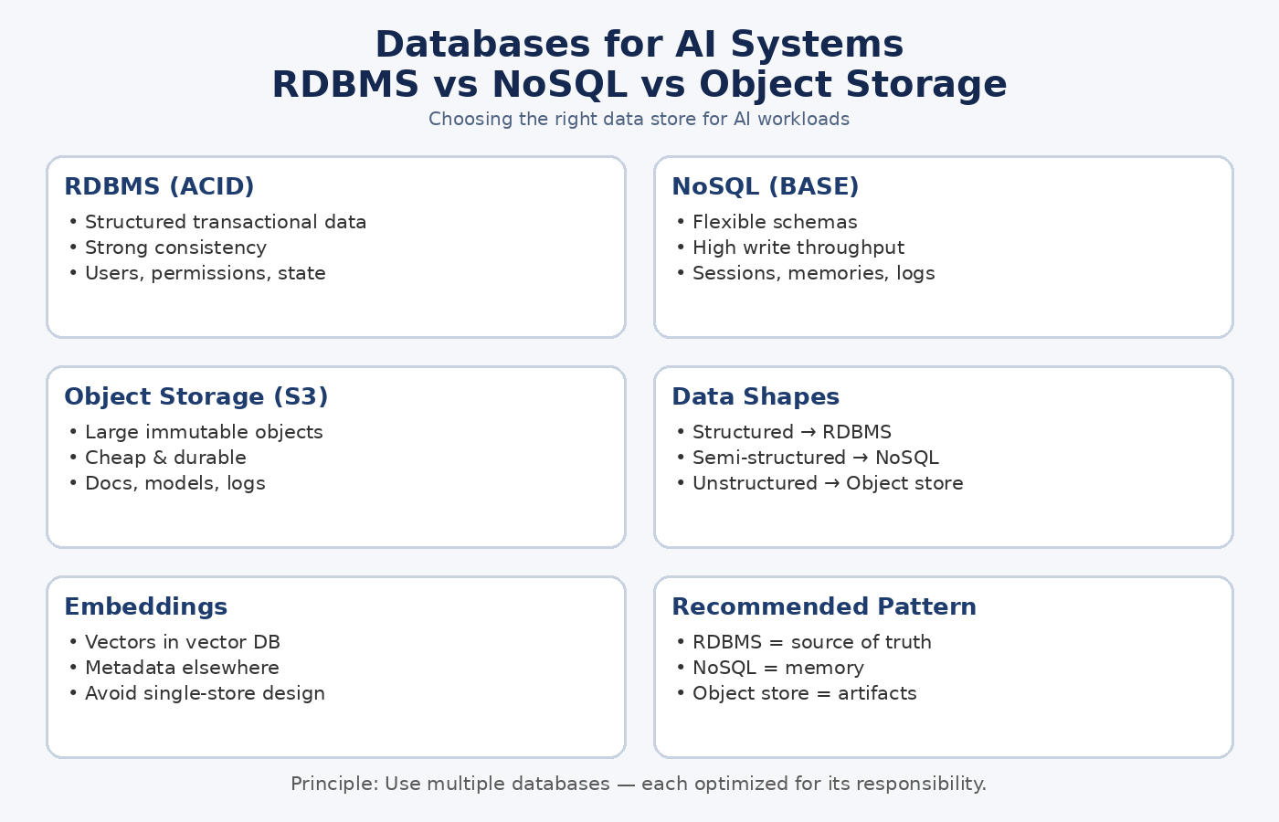

🚀 POST 17 — TOONs (Task-Oriented Orchestration Networks)

**#AI** **#GenAI** **#MultiAgent** **#SystemDesign** **#Architecture**

Most multi-agent systems today fall into one of two buckets:

a) Static DAG-based workflows

b) LLM planners that “think” their way through tasks

Both work — but both start to break down at scale.

This is where TOONs (Task-Oriented Orchestration Networks) become powerful.

🔵 1️⃣ What Are TOONs?

A TOON is a task-centric orchestration model, not an agent-centric one.

Instead of asking:

“Which agent should act next?”

TOONs ask:

“What task must be completed next, and which capability can best handle it?”

Tasks drive the flow — agents are assigned dynamically.

🔵 2️⃣ Why TOONs Matter for Multi-Agent Systems

As systems grow:

a) Agent counts increase

b) Capabilities overlap

c) Workflows branch dynamically

Agent-first designs become brittle.

TOONs provide:

✔ Clear task boundaries

✔ Deterministic orchestration

✔ Better observability

✔ Easier governance

They scale by design, not by prompt engineering.

🔵 3️⃣ TOONs vs DAG-Based Workflows

A DAG (Directed Acyclic Graph) represents a fixed execution flow—common in RAG and pipeline-based AI systems—where steps run in a predefined order.

DAGs

a) Static paths

b) Predefined edges

c) Hard to adapt at runtime

TOONs

a) Dynamic task graphs

b) Conditional routing

c) Runtime task creation

DAGs encode flow.

TOONs encode intent.

🔵 4️⃣ TOONs vs LLM Planners

LLM planners:

a) Are flexible

b) But opaque

c) And hard to debug

TOONs:

a) Use explicit task states

b) Separate planning from execution

c) Limit LLMs to bounded decisions

Result:

✔ Less hallucination

✔ More predictable behavior

✔ Stronger enterprise control

🔵 5️⃣ Where TOONs Outperform

TOONs shine when:

a) Workflows are long-running

b) Tasks have dependencies

c) Multiple agents can fulfill the same role

d) Failure recovery matters

e) Compliance & auditability are required

Healthcare, finance, ops, and enterprise automation benefit the most.

🔵 6️⃣ Mental Model

Think of TOONs as:

A control plane for tasks, not a chat between agents.

Agents become workers.

Tasks become first-class citizens.

🔵 Principle: Orchestrate Tasks, Not Just Agents

If agents are your “how,”

Tasks are your “what.”

Robust systems always start with the what.

🔽 Up Next: Post 18 — Best Frameworks for Building AI Agents & Systems

Stay tuned.

**#AIArchitecture** **#Agents** **#EnterpriseAI** **#Orchestration**

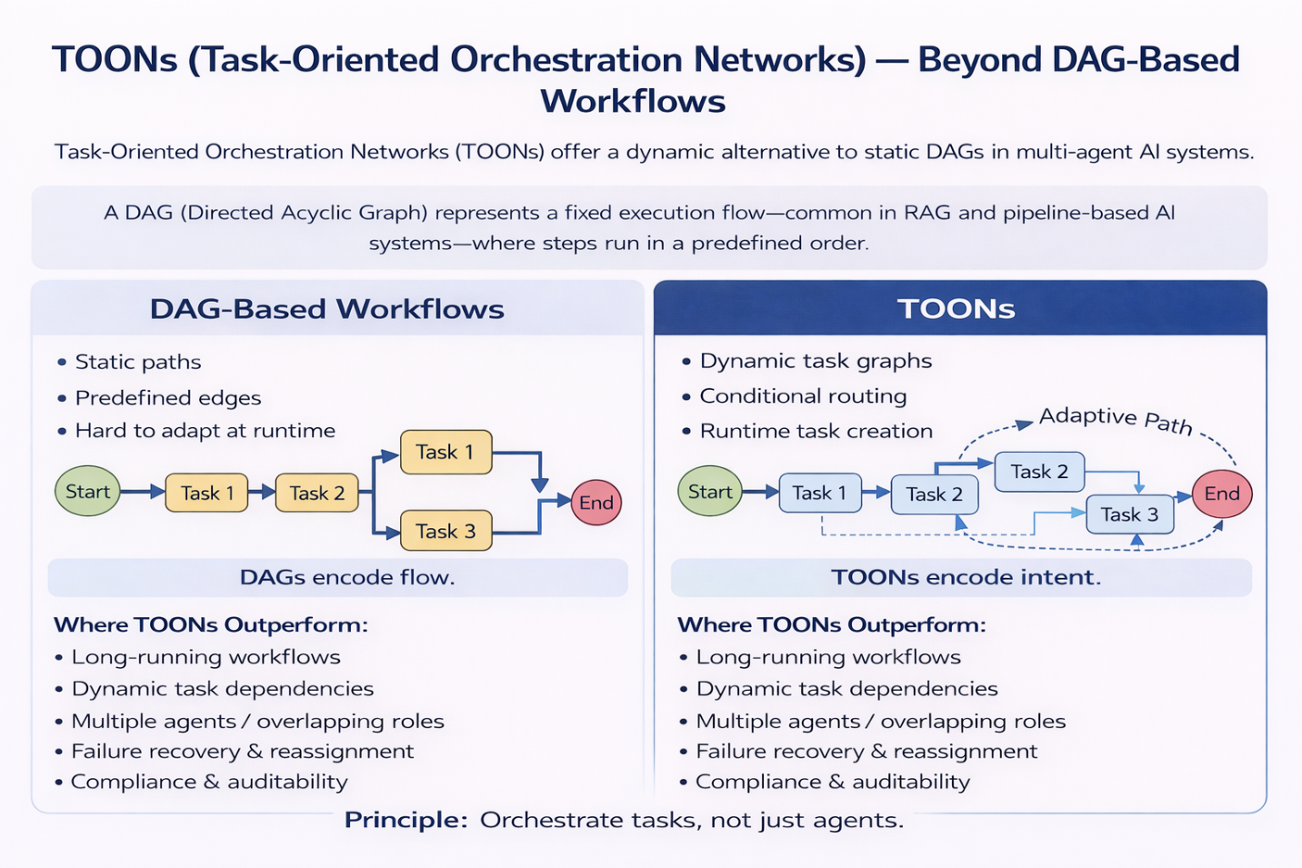

🚀 POST 18 — Best Frameworks for Building AI Agents & Systems

**#AI** **#GenAI** **#Agents** **#SystemDesign** **#Architecture**

After agent design, orchestration, memory, and scaling, the next question is inevitable:

Which framework should I use?

There is no single “best” framework — only the right abstraction for the problem, scale, and governance model.

Here’s a concise, architect-level view 👇

🔵 LangChain — Rapid Composition

✔ Fast prototyping, tool chaining

❌ Needs extra governance at scale

Use when speed > control.

🔵 LangGraph — Stateful & Deterministic

✔ Explicit flows, state, observability

❌ Higher upfront design effort

Use when reliability > flexibility.

🔵 Haystack — Enterprise RAG

✔ Retrieval-first, production-friendly

❌ Less agent-centric

Use when search & retrieval dominate.

🔵 Transformers Agents (Hugging Face) — Research-Oriented

✔ Deep model control

❌ Orchestration left to the user

Use for experimentation, not pipelines.

🔵 Ollama + RAG — Local-First

✔ Privacy, zero API dependency

❌ Limited horizontal scale

Use for POCs, internal tools, edge setups.

🔵 MCP Servers — Tool Control Plane

✔ Auth, sandboxing, governance

❌ Requires platform thinking

Use when tools must behave like production APIs.

🔵 Custom Minimal Frameworks (Common End State)

✔ Full control, minimal abstraction

❌ Higher engineering responsibility

Frameworks should accelerate, not own, your architecture.

🔵 Principle

Choose the smallest framework that solves today’s problem.

Add structure only when the system demands it.

Frameworks are scaffolding — architecture is permanent.

🔽 Up Next: Post 19 — MCP Codegen & Sandbox Execution

**#EnterpriseAI** **#LLM** **#MCP** **#Architecture**

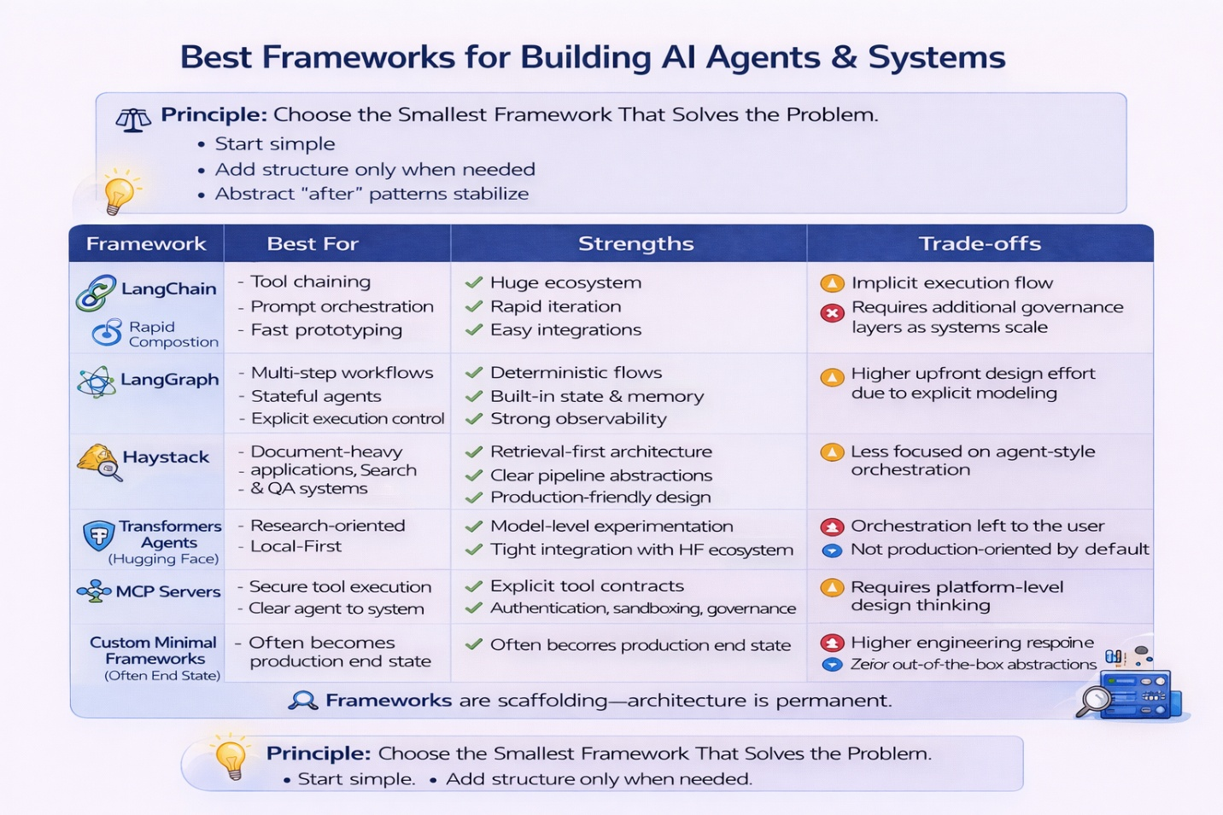

🚀 POST 19 — MCP Codegen & Sandbox Execution (Deep Technical)

**#AI** **#GenAI** **#MCP** **#Agents** **#SystemDesign** **#EnterpriseAI**

As AI agents move from chatbots to action-taking systems, one question becomes critical:

How do we let LLMs execute code and tools safely?

This is where MCP (Model Context Protocol) becomes foundational.

🔵 1️⃣ What MCP Actually Enables

MCP turns tools into first-class, discoverable capabilities.

Instead of hardcoding functions:

a) Tools are exposed via MCP servers

b) Agents discover them dynamically

c) Execution is contract-driven, not prompt-driven

Think of MCP as an API layer for agents.

🔵 2️⃣ Codegen ≠ Blind Execution

LLMs don’t “run code” directly.

With MCP:

a) LLMs generate intent (structured calls)

b) MCP validates inputs & schemas

c) Execution happens outside the model

This separation is what makes agent systems safe.

🔵 3️⃣ Sandboxed Tool Execution (Non-Negotiable)

Every MCP tool should run inside a sandbox:

✔ Isolated runtime

✔ No unrestricted filesystem or shell access

✔ Controlled network egress

✔ Strict input/output schemas

Agents should request capabilities, not inherit power.

🔵 4️⃣ Tool Permissioning & Trust Boundaries

MCP supports:

a) Tool-level authorization

b) Scoped credentials

c) Role-based agent access

d) Expiring tokens

Treat MCP servers like production services, not helpers.

🔵 5️⃣ Risks & Mitigations

Risks:

a) Prompt-driven misuse

b) Over-permissive tools

c) Infinite execution loops

Mitigations:

✔ Schema validation

✔ Rate limits & timeouts

✔ Capability allowlists

✔ Auditing & observability

Security lives around the model, not inside it.

🔵 6️⃣ MCP 2.0 — Where This Is Going

Emerging directions:

a) Richer tool discovery

b) Standardized sandbox policies

c) Agent-to-agent interoperability

d) Platform-level governance

MCP is evolving into a control plane for agent execution.

🔵 Principle

Agents should reason freely — but act under strict constraints.

MCP makes that possible.

🔽 Up Next: Post 20 — Final Blueprint for Enterprise-Ready Agentic AI

Stay tuned.

**#MCP** **#AIArchitecture** **#Agents** **#Security** **#Orchestration**

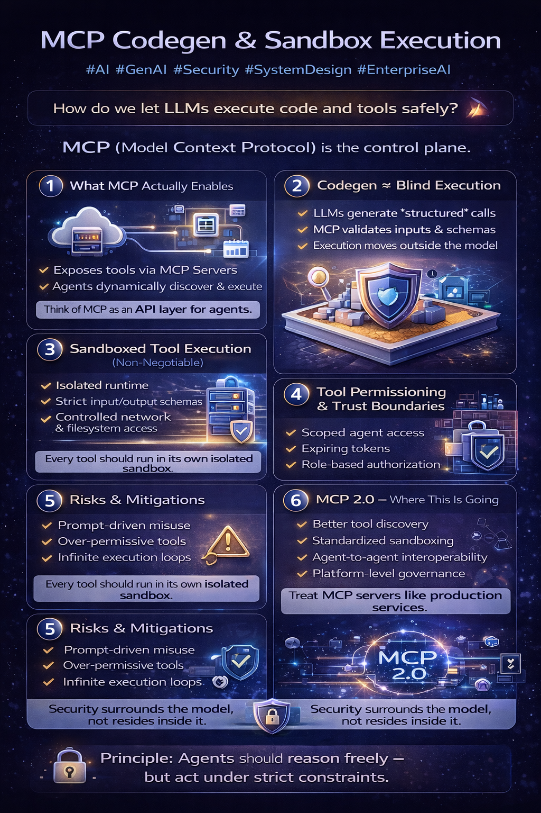

🚀 POST 20 — Final Blueprint for Enterprise-Ready Agentic AI Architecture

**#AI** **#GenAI** **#AgenticAI** **#SystemDesign** **#EnterpriseAI**

This post closes my series on AI / GenAI System Design.

Across these posts, I intentionally avoided tool hype and focused on how AI systems are actually built in enterprise environments.

Here’s the distilled blueprint 👇

🧱 1️⃣ Architecture Before Models

LLMs are components — not the system.

Production AI systems are shaped by:

a) Orchestration

b) Retrieval & memory

c) Tool execution

d) Guardrails & governance

e) Observability & failure handling

Architecture determines reliability long before model choice.

🧠 2️⃣ Start Simple, Scale Deliberately

Most systems evolve like this:

RAG → Single Agent → Tool-using Agent → Multi-Agent → Task-Oriented Orchestration (TOONs)

Jumping straight to complexity creates fragile systems.

⚙️ 3️⃣ Frameworks Accelerate — Architecture Endures

Frameworks help teams move faster:

a) Agent orchestration: LangChain, LangGraph, Google ADK

b) Multi-agent coordination: CrewAI, AutoGen, OpenAI Swarm

c) Tool execution & governance: MCP

But in production, architecture outlives every framework.

Choose frameworks as scaffolding — not foundations.

🔐 4️⃣ Guardrails Enable Scale

Enterprise-ready systems require:

a) Explicit tool contracts

b) Sandboxed execution

c) Permissioned access

d) Deterministic fallbacks

e) Auditability

Security surrounds the model — it does not live inside it.

🗂️ 5️⃣ Use the Right Storage for the Right Responsibility

a) RDBMS → truth, identity, permissions

b) NoSQL → agent & session state

c) Vector DB → embeddings

d) Object storage → documents, logs, artifacts

No single database should do everything.

🧭 Core Principle

Reason freely. Act under constraints.

That’s how agentic systems become enterprise-ready.

I’ll be turning this series into a single blueprint PDF with a clean architecture diagram and design checklist.

If this series helped you think more clearly about AI system design, feel free to share or comment — that’s how good architecture conversations grow.

**#AI** **#GenAI** **#SystemDesign** **#Architecture** **#EnterpriseAI**

